Environmental Consciousness and Green Purchase Intentions: A Study of Indian University Campuses

¹Shashi Kant Dikshit, ² Bharath Sampath

^{1&2} Assistant Professor, CMS B-School, Jain (Deemed to be) University, Bengaluru, Karnataka, India, ³ Assistant Professor

Abstract:
The indiscriminate consumption patterns across the world, including India, have led to severe issues such as pollution and global warming, highlighting the need for greater awareness and consumption of green products. The primary goal of this study was to evaluate how awareness of green products influences the green purchase intentions of university students in India. Specifically, the study aimed to determine whether awareness, price, availability, value, and quality influence students’ intentions to buy green products and to assess how these factors predict their purchasing behavior. Data from an online survey of 350 university students were analyzed using structural equation modeling. The findings revealed that awareness, price and availability of the green product have a significant relationship with green perceived value. Green perceived value has the significant relationship with perceived qulity of green product and finally perceived quality significantly impact the purchase intension of university students. This study is among the first to conclude that in the Indian context, students' awareness of green products significantly affects their purchase intentions, primarily driven by price, availability, information, value, and exceptional quality. The study's implications, limitations, and directions for future research are also discussed.

Keywords: Green products awareness, Green marketing, Green purchase intentions, Emerging market

Introduction:
In country like India, where population is growing very fast and due to this rapidly changing consumption pattern are significantly contributing to the environmental problem. This changing consumption pattern is causing many environments related problem like depletion of natural resources, growing greenhouse gas emission, and majorly the global warming. The only solution to save the environment is to go green and use the sustainable product. It is need of time to consume more of green product to save the environment. According to statistics (2022 revision of the World Population Prospects), 65% of the population of India is below 35 years and almost 50% population of India is below 235 years. These statistics shows that this youth of India can bring this change. Indian youth can act as the catalyst and lead the process of going “green”. This concept of green is often associated with theories like sustainability, green product consumption, reduce wastages, social responsibility toward environment and normally provide the platform for green consumption across the globe so as in India too.

Environmental awareness among the youth population is growing rapidly due to various factors like open and easily available information, initiative taken by the society, social media campaigns etc. A study by Centre for Science and Environment (CSE) found that Indian youth very much concerned about the environment and understand their responsibility towards environmental issues like climate change, pollution, resource wastages deforestation. This awareness among youth of India led to a surge in youth-led initiatives, from sustainable living projects to community-based environmental campaigns.

This rapidly growing awareness about the environment also putting pressure on the consumers to consider the suitability and garnered interest in the business of going green through the use of environmental-friendly products. Indian consumers with growing knowledge about the pollution, climate change, recourse wastages and depletion, acting as a more responsible consumers and looking environmentally conscious choice. The shift in the behaviours of the consumer, where they are moving toward the eco-friendly life style, led to a surge in the demand of the sustainable and eco-friendly products. This amplified awareness due to the information as well as the social media role, is also working as catalyst to boost the demand of the sustainable products. Yet this green consciousness in emerging markets like India is still low, therefore, stirred up public worry in emerging economies and causing businesses to embrace green marketing targets in order to keep their customers.

In current time, green product can be seen as one of the most needed solution for the environmental problems. It is also advocated that the green product can play a vital role sustainable development of the environment and this is the reason that, in 2015, sustainable development goals were launched by the government. The goal 12 of the SDGs stipulates “responsible consumption and production patterns” by 2030. Apart from this, several significant steps have taken by the government of India to promote sustainable development among youth, encompassing various sectors and dimensions. That is resulted in remarkable rise in environmental awareness among Indian population specially youth in India. In one of their research, it was mentioned by the Bain & Company, that 60% of Indian consumers are ready to spend more for eco-friendly products.

India, as one of the fastest-growing economies, has neglected the issue of minimizing environmental impact while focusing on waste reduction, sustainable living, and improving efficiency. This makes it essential for Indian consumers to modify their consumption and production habits, as failing to do so could pose a significant obstacle to protecting the environment from irreversible harm. To promote sustainable consumption, fostering a deeper understanding of the environmental and social impacts of products is the only viable solution. Despite the country’s significant growth, Indian consumers remain largely unfamiliar with green products and its benefits. I find that, not much researches have been conducted on the awareness of green products among students specially the university post graduate students in India's emerging market.

In light of this, the primary objective of this study is to evaluate the impact of university students' awareness of green products on their green purchasing intentions. The specific objectives of this paper are as follows:
- To understand the influence of awareness, price, availability and quality of the green product on university students’ intention to purchase green products.
- To relationship of awareness, price, availability and quality of the green product with university students’ intention to purchase green products

Literature review and Hypotheses development
Environment Consciousness has become the prominent factors in current market. Consumers are aware of the negative environmental impact due to their action and looking for sustainable products and services to save the environment. This behaviour of the consumers is forcing company to adopt the environmentally conscious strategies and introduced the sustainable product and services. Undoubtedly, the consumer green purchase intension is influenced by their concern about the environment and usefulness of the product still in most of the cases, it is difficult to convert this into purchase of the green product. In previous research, it was found that even the customer is concerned about the environment still their intension does not directly translate into consumption or purchase of the green product. According to Dangelico & Vocalelli (2017), for organisation also sustainability is the third aim after profitability and customer satisfaction.

To understand the factors influencing the purchase intention of green products, green product awareness(GPAW), green product price (GPP), green product availability (GPA), green perceived value (GPV) are taken into consideration.

Green Products & Green Consumers:
Green products or eco-friendly products are the one that do not harm the environment and are environmentally friendly. According to Kotler & Armstrong (2021), “Green products are goods or services that are considered environmentally friendly throughout their entire lifecycle. In other words, green products can define as the healthy products, can be recycled, can be reuse, and more energy efficient. Green products help in developing the sustainable environment.

According to Solomon, Russell, & Greenfield, (2001), “green consumer is an individual who makes conscious purchasing decisions with the aim of minimizing their environmental impact”. Green consumers are defined as the consumer those who consume the eco-friendly product or avoid using toxic product that harm the environment. Green consumers consume products and services that are environmentally friendly and sustainable. According to Surya R, Hajamohideen OM (2018), who avoid any product which causes harm or damage to any living organism and destroys the environment during manufacturing or consumption.

Green Perceived Intention (GPI):
Green perceived intention can be defined as the belief of the consumer that they will show their engagement in purchasing of green products. This also can be defined as the subjective probability of consumer engagement in green purchase. According to Ajzen, I. (1991), “it is the individual's intention to purchase environmentally friendly products or services”. This green perceived intention is critical determinant of the green purchase where consumer with strong green perceive intention follow their intention and more likely to purchase eco-friendly product. According to Ansu-Mensah, P. (2021) several factors effect this perceived intention like Environmental knowledge and awareness, Green perceived price, green perceived availability, green perceived value, green perceived quality. These factors directly or indirectly affect the green perceived intention that finally influence the purchase decision of the Indian consumer.

Green Perceived Quality (GPQ):
Green perceived quality denotes the overall quality of the green products. Kim, & Choi (2011), in one of their research paper mentioned that green perceived quality refers to a “consumer's perception of the environmental benefits or attributes associated with eco-friendly product or service.”. It is basically the perception of the consumer that offer the benefit to the environment. Green perceived quality is subjected to the consumer’s subjective judgment and ecological perspectives. This perception of the consumer significantly impacts the purchase intention of the green products. This means that consumer is more likely buy the product that offer quality and sustainability. According to Kim & Choi (2011), Consumers are more likely to buy the green product if they perceive that the green products has high quality in terms of environmental benefits. Based on above discussion, it is suggested that;
H5: Green perceived Quality (GPQ) positively influenced the green perceived intention

Green Perceived Value (GPV):
Green perceived value is another factor that are closely relation green product purchase. Green perceived value refers to the consumer’s overall assessment regarding the benefit they received from eco-friendly products or services. Green perceived is closely related to the quality and act as a catalyst in buying the green product. Consumer perceive that the green product having higher benefit must be having better quality and worth buying. This relationship indicate that the consumer accesses the quality of the product based on the value they offer. This connection is more crucial as consumer who feel that the green products are environmentally beneficial are having superior quality. According to Kim & Choi (2011), Consumers who perceive that the green product offer more value or the benefit in relation to environment sustainability are more likely to ignore minor imperfection about the green product to assess the quality of the green product. This perceived value about the green product create a better impression that positively affect the green perceived quality. To understand this relation, it is stated that;
H4: Green perceived value positively influenced the green perceived Quality

Green Product Awareness (GPAW):
In this study, one of the independent factor that was taken into consideration is Green Product Awareness (GPAW). It is evident that consumer must be aware about the product before purchasing the product and the same applies in case of green product. This awareness is defined as the information consumer are having regarding green product available in the market. According to Ansu-Mensah, P. (2021), Information about the green product benefits likely to enhance the green perceived value. According to Peattie and Crane (2005), Awareness about the green product enhance the perceived value of money spent on green products or related items. According to Ramayah T, Lee JWC, Mohamad O (2010), consumers of green products are agreeing with the fact that green products help in environment sustainability. As consumer are more aware about the environmental impact, they are also aware about the long-term cost benefit associate with the green products. This shift in the mind-set of the consumer helps them to relate the purchase green purchase with green perceived value. Based on above discussion, to understand this relation it is stated that;
H3: Green products awareness is positively influenced the green perceived value.

Green Perceived price (GPP):
Price criterion play a very important role while considering green product purchase. Green perceived price refers to the cost consumer pay to buy the environment friendly product whereas the green perceived value refers to the benefit associated with purchasing of environmentally friendly products. It is evident that when consumer perceived that green product is prised reasonably and affordable, their overall perception about the green product value enhance significantly. According to khan at al 2016, higher price of green product sometimes increased the perceived value as consumer relate the product with premium quality and greater environmental benefit. Where as in some cases, the consumer may also take this negative in term of affordability and postpone the purchase of the green product. In this case, the relationship between perceived price and perceived value will be very low. To understand the relationship, it is stated that:
H2: Green perceived price positively influenced the green perceived value.

Green Perceived Availability (GPA):
Availability of the green product is another factor that directly or indirectly influence the green product purchase. Green perceived availability can be defined as the believe of the consumer about the availability of the green products in the market. According to Dangelico & Vocalelli (2017), the availability of the green product significantly impacts the green perceived value when consumer perceived that the green products are easily available in the market, consumers are more likely view them as valuable and consider for purchasing. This relationship suggest that availability create the value and this value enhance the purchasing decision. To understand the relationship, it is stated that:
H1: Green perceived availability positively influenced the green perceived value

Conceptual Framework:
Based on above discussion, the following framework was developed.
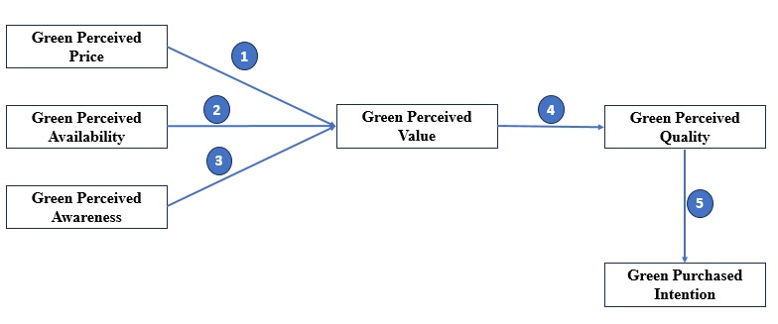

Research Methods:
The purpose of the study was to understand the relationship of awareness about green products and their impact on purchase intention. The measurement items were adopted from previous study Peter & Mensah (2021) and after the extensive deliberation with experts and academicians the total 28 items were used in this research and categorised under 6 constructs (GPQ, GPP, GPA, GPAW, GPV and GPI), termed as latent variables. To measure the constructs like GPQ 5 items, GPP 4 items, GPA 5 items, GPAW 4 items, GPV 5 items and GPI 5 items used. To understand this relationship, the target audience comprises of management students (only Postgraduate and Doctorate students) of different university of the India situated in different cities. To achieve the investigator’s aim to establish a clear relationship between the variables used in the research, questionnaire was developed using 9 scale (1 to 9) with 1 being “Strongly Disagree” to 9 being “Strongly Agree” and Students were asked to rate their perception about the variables. These respondents were surveyed through personal interaction and prior consent was taken from the students before the survey. This survey was the monitored. Objective of the survey and questionnaire was clearly defined before the distribution of the questionnaire. Total 350 questionnaires were distributed, out of which 337 responses were finally used for the study. The questionnaire was divided into two section A and B where questions related to all the variables of the study was part of the section A and Section B was all about demographic questions. Much consideration was taken into care while designing the questionnaire to avoid the ambiguity as well as the errors. Final data analysis was done using the SmartPLS software.

Data Analysis:
The analysis of the measurement model and structural model was done using the data collected with the help of using SmartPLS software. Sample size is one of the major issues while using SmartPLS and different researchers are having different opinion on the same. This sample size of 350 taken for this research justify the basic requirement of PLS-SEM, in which sample size must be 10 times the number of items in the model (24items*10=240 Samples). (Hair et al,2014). To test the designed model Common Method biasness, construct’s reliability, convergent validity, and discriminant validity was examined.

Result and Discussion:

Common Method Biasness (CMB):
CMB refer to the systematic error and helps to ensure the validity of the research. No common threshold is still defined. This depends on the various factors like technique used, type of research like social science or other. Still, it’s advisable to keep the variance between 10-20% keeping in mind the ideal condition. Technique like Harman’s single factors test, explain a large proportion and typically more than 50% of the variance may indicate the problem but in “behavioral research we ignore the higher value”. (Fuller, Simmering, Atinc, Babib, 2015). To understand the common method biasness in the data, we used Harman’s single factor test and this test explained 52.4% of total variance, which is off course not below 50% but we have ignored this because this normally happen in behavioral research. (Fuller, Simmering, Atinc, Babib, 2015)

Variable | Frequency | Percentage | To justified the hypothesis, SmartPLS- SEM was used. To understand the Sampling adequacy, adequacy for EFA, reliability for more valid conclusion, exploratory factor analysis was done and the KMO value .903 considered excellent and suggest good sampling adequacy, high common variance. The factor loading (Table 1.2) also having values greater than 0.7 except overloaded and optimistic and represent sufficient variance from the construct.
Age
19–21 | 279 | 83
22–25 | 37 | 11
26–30 | 18 | 5
31 + | 3 | 1
Gender
Male | 129 | 38 | Location
Female | 208 | 62 | State | Frequency
Education |  |  | Uttar Pradesh | 113
Pursuing P. G. Diploma | 44 | 13 | Karnataka | 157
Pursuing P.G. Degree | 229 | 68 | Maharashtra | 42
Doctoral Students | 64 | 19 | Haryana | 25
Table 1: Demographic Detail

Measurement Model:
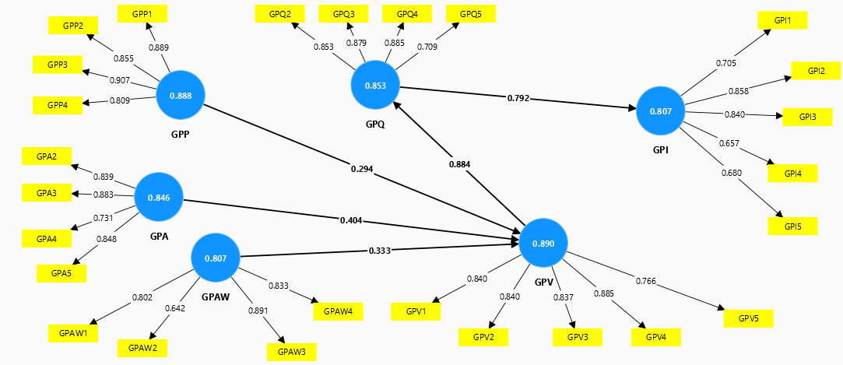
Fig 1: Green Purchase Intention Model – Factors Analysis
Reliability Analysis:
After the careful examination of the overloading some of the items was removed from the study because these items like GPQ1=0.432 and GPA1=0.411 had very low loading (below .60). After the removed items 26 items were used in this research to measure the constructs like GPQ 4 items, GPP 4 items, GPA 4 items, GPAW 4 items, GPV 5 items and GPI 5.

Convergent Validity:
To measure the convergent validity, the outer loading, composite reliability and average variance extracted was computed with the help of SmartPLS algorithm. To check the indicator reliability, the factor loading values are examined and found perfect as all the items of green product purchase are greater than 0.6. Cronbach's alpha, Composite reliability and AVE all are having values higher values than recommended value of 0.7, 0.7 and 0.5 respectively which verify and validate convergent validity. (Table 2)

Discriminant validity was also tested for the reflective measurement model. To measure this Fornell Lacker benchmark method was used, where the square root of AVE with the construct’s correlation was taken into consideration. As all the values of the constructs were beyond the Squared correlations among the constructs, this satisfied the criteria of Discriminant validity. (Table 3)
Constructs | Items | Weights | Cronbach's alpha | Composite reliability (rho_a) | Composite reliability (rho_c) | Average variance extracted (AVE)
Green Purchase Intention | GPI1 | 0.705 | 0.807 | 0.824 | 0.866 | 0.567
Green Purchase Intention | GPI2 | 0.858
Green Purchase Intention | GPI3 | 0.84
Green Purchase Intention | GPI4 | 0.657
Green Purchase Intention | GPI5 | 0.68
Green perceived quality | GPQ2 | 0.853 | 0.853 | 0.872 | 0.901 | 0.697
Green perceived quality | GPQ3 | 0.879
Green perceived quality | GPQ4 | 0.885
Green perceived quality | GPQ5 | 0.709
Green perceived price | GPP1 | 0.889 | 0.888 | 0.899 | 0.923 | 0.750
Green perceived price | GPP2 | 0.855
Green perceived price | GPP3 | 0.907
Green perceived price | GPP4 | 0.809
Green perceived availability | GPA2 | 0.839 | 0.846 | 0.862 | 0.896 | 0.684
Green perceived availability | GPA3 | 0.883
Green perceived availability | GPA4 | 0.731
Green perceived availability | GPA5 | 0.848
Green products awareness | GPAW1 | 0.802 | 0.807 | 0.842 | 0.873 | 0.636
Green products awareness | GPAW2 | 0.642
Green products awareness | GPAW3 | 0.891
Green products awareness | GPAW4 | 0.833
Green perceived value | GPV1 | 0.84 | 0.890 | 0.893 | 0.920 | 0.696
Green perceived value | GPV2 | 0.84
Green perceived value | GPV3 | 0.837
Green perceived value | GPV4 | 0.885
Green perceived value | GPV5 | 0.766
Table 2: Loading, Cronbach’s alpha, CR and AVE

 | GPA | GPAW | GPI | GPP | GPQ | GPV
GPA | 0.827
GPAW | 0.790 | 0.797
GPI | 0.725 | 0.772 | 0.753
GPP | 0.787 | 0.755 | 0.770 | 0.866
GPQ | 0.821 | 0.724 | 0.751 | 0.794 | 0.835
GPV | 0.811 | 0.732 | 0.712 | 0.821 | 0.812 | 0.834
Table 3: Fornell – Larcker Criterion

Structural model
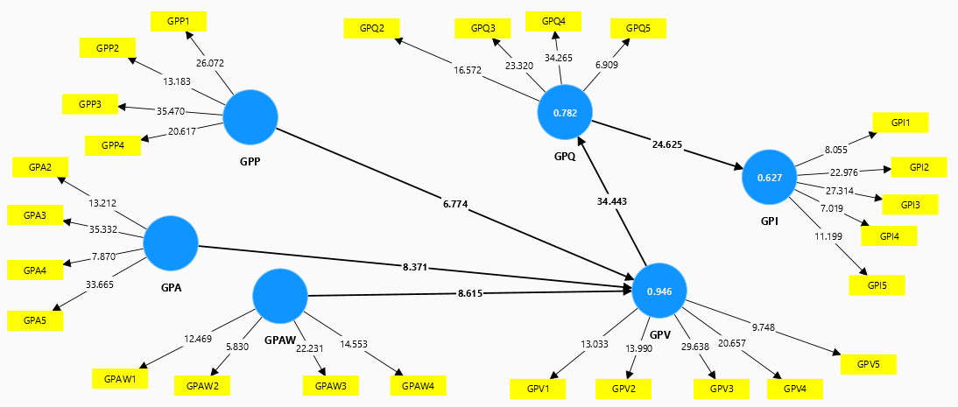
Fig 2: Green Purchase Intention Model – Structural Model

Another main aspect of this study is to build and evaluate the structural model. The r-square, standard deviations, the t-values, the p-values and the path coefficients were all completed, and these results are subsequently presented in Tables 4, and 5 respectively.

R-Square was one of the criterions to evaluate the SM. This value of R-Square explained the variance by the exogenous constructs. As suggested by the Cohen (1988), the accepted tolerable of R-square should be >026 means 26% min. According to the value (Table 5) shown, the values are showing satisfactory level of prediction (62.7%, 78.1% and 94.7%).

Finally, this SM used to test the hypothesis and understand the significance of the relationship
Table 4: Direct Relationship- Hypothesis from H1 to H5
 | β | T | P
H1: Green perceived price -> Green perceived value | 0.293 | 6.774 | 0.000
H2: Green perceived availability -> Green perceived value | 0.403 | 8.371 | 0.000
H3: Green products awareness -> Green perceived value | 0.336 | 8.615 | 0.000
H4: Green perceived value -> Green perceived Quality | 0.884 | 34.443 | 0.000
H5: Green perceived quality -> Green Purchase Intention | 0.792 | 24.625 | 0.000

To test the direct relationship, consistent bootstrapping was done with 5000 resample at 95% confidence interval using two-tail percentile bootstrap confidence Interval method. The result is shown in Table 4. The result shows that all the five hypotheses (H1 to H5) are significant and accepted. Its is evident that when beta value is <0.20, T-statistics is <1.96 and p-value is >0.05, the particular hypothesis is do not have the significant relationship. To understand the relationship beta, T statistics and p value was calculated. It is noted that the beta values are >0.20, positive and T statistics are > 1.96 @ 5% for all the hypothesis (H1, H2, H3, H4, H5) defined (Table 4). This shows that all the relationship are positive in nature and having significant impact (considering beta and T statistics).
 | R-square | R-square adjusted
GPI | 0.627 | 0.623
GPQ | 0.782 | 0.779
GPV | 0.946 | 0.945
Table 5: R Square & R-square adjusted

Discussion:
The result points out that the variance of the dependent variable “Green Perceived value” is 94.6% and defined by the 3 (three) predictors of GPV, Green Perceived Price, Green Perceived Availability and Green Perceived Awareness. The variance of dependent variable Green Perceived Quality is defined by Green Perceived Value is 78.2% (0.782) and the variance of dependent variable Green Perceived Intention is defined by Green Perceived Quality is 62.7% (0.627). All these values imply that the Green Perceived Intention is very well explained by this model in university students in India. This study reveals that the Green Perceived Price, Availability and Awareness create value for the university students. Therefore, uuniversity students perceive greater value in green products due to factors such as perceived pricing, product availability, and awareness of environmental benefits. In another relationship, University students associate higher perceived quality with green products, likely due to the perceived value they attribute to these items. Finally, all this led to green product intention, where the university student’s keenness to buy the green product triggered by their lucid evaluation of quality of the product they receive.

According to university students, the products that are environment friendly, give more value to money, price is one factor that define the value more benefit in comparison to other normal products and given them value for what they pay. They are ready to pay the price for the product that are environmentally friendly and easily available in the market. This value of green product makes them superior in term of quality to the conventional products available in the market. University students believe that green products offer unique benefits like environmental advantages, health benefit etc. beyond their basic utility. University students feels that a green product to having higher value must possess higher quality. This shows that university students associate the product's environmental or sustainable attributes with superior performance, durability, or safety. In essence, green perceived value acts as a catalyst for perceiving green quality, making consumers more willing to pay a premium for sustainable options.

As University students believe that the green products are superior to traditional products and having higher green quality, they are more likely to buy the green products even if they may be costly than the traditional products.

Conclusion & Implications:
To examined the effect of green product awareness of university students on their green product purchase intention, two objectives was defined. The specific objective of the study was, (1) to identity whether the factors price, availability, awareness, value and quality influence the green purchase intention to buy the green products, (2) To define the relationship between the factors mentioned in objective (1).
The study results suggested that the factors like price, availability, awareness, value and quality play a very vital role in buying the green products among university students in India. The study reveals that green price, availability of green products and the awareness about the green products create the value for the money for university students and they find value in buying the green products. This perceived value for the green products makes them better / superior in term of quality with traditional products. This perceived quality has the significant positive impact on university students’ green products purchase intention

This research can contribute in shaping the market of environmentally friendly and sustainable products. When a university student, prospect buyers, express the interest in buying the environmentally friendly products and ready to pay the higher price, this can create the strong demand of the sustainable products. By choosing the environmentally friendlily products, they have shown their support for the environment and ready to contribute in reducing the environmental footprints. If motivate, they can act as the catalyst for society and influence their peers, family and society to adopt more sustainable behaviours.

As a result, the policy makers, the manufactures, government could influence value and quality of the green products to increase the acceptability of the green products in the society. With the help of marketing campaign, they may improve the knowledge and understating about the green products and increase the positive approach regarding the green product purchase. As Green perceived awareness is the one of the major factors that contribute to the value creation for green product, the educated youth can contribute in green as well as sustainable product. As they are ready to pay more, the motivation and knowledge are the two important area that need to be discussed for green product demand.

Limitation and Future Research:
This study was conduct among graduate students, keeping in mind that they are acting as decision make in today’s society and also buy products for their family. The research was conduct in different university / college in different locations still can’t be generalised with the sample taken. In future, undergraduate can be included from different cities to make study more diversified. This study is mainly taking about their intension to buy the products. In future, we can go one step ahead to discuss the post purchase behaviour of the individual who buy the green products. We can even take any specify category of the green product like cosmetics or food items or consumer durables to understand the intention or behaviour of the individuals.

Reference:
- Ajzen I (1991) The theory of planned behavior. Organ Behav Hum Decision Process 50(2):179–211

- Ansu-Mensah, P. (2021). Green product awareness effect on green purchase intentions of university students’: an emerging market’s perspective. Future Business Journal, 7(1), 1-16. DOI: 10.1186/s43093-021-00094-5

- Centre for Science and Environment (CSE). (2023). "Youth and Environment: A Growing Concern." CSE Report.

- Chauhan, R., & Sharma, S. (2020). "Environmental Education and Awareness: A Study of Indian Youth." Journal of Environmental Studies, 31(2), 123-132.

- Christie M. Fuller, Marcia J. Simmering, Guclu Atinc, Yasemin Atinc, Barry J. Babin, (2016), Journal of Business Research, Volume 69, Issue 8, 2016, Pages 3192-3198, ISSN 0148-2963, https://doi.org/10.1016/j.jbusres.2015.12.008.

- Dangelico RM, Vocalelli D (2017) “Green Marketing”: an analysis of definitions, strategy steps, and tools through a systematic review of the literature. J Clean Prod 165:1263–1279

- Kim, T. H., & Choi, S. M. (2011). The influence of green perceived quality on green purchase intentions: The mediating role of green trust. Journal of Business Research, 64(11), 1274-1282.

- Kotler, P., & Armstrong, G. (2021). Principles of marketing (17th ed.). Pearson.

- Kumar, A., & Singh, A. (2021). "The Role of Social Media in Promoting Environmental Awareness among Indian Youth." International Journal of Information Management, 59, 102412.

- Mishra, A., & Pathak, S. (2019). "Youth Engagement in Environmental Conservation: A Case Study of India." Journal of Sustainable Development, 12(3), 345-355.

- Peattie, A., & Crane, A. (2005). Green marketing: A managerial perspective. Journal of Business Ethics, 56(3), 235-252.

- Peter Ansu‑Mensah,(2021), ﻿Future Business Journal, 7(1):48 https://doi.org/10.1186/s43093-021-00094-5

- Ramayah T, Lee JWC, Mohamad O (2010) Green product purchase intention: some insights from a developing country. Resour Conserv Recycl 54(12):1419–1427. https:// doi. org/ 10. 1016/j. resco nrec. 2010. 06. 007

- Sharma, P., & Singh, R. (2022). "Environmental Awareness and Behavior of Indian Youth: A Review." Journal of Environmental Management, 298, 113610.

- Solomon, S., Russell, J. A., & Greenfield, K. (2001). Consumer behavior: Buying, having, and being (5th ed.). Prentice Hall.

- Surya R, Hajamohideen OM (2018) A qualitative study on consumers’ attitude and behaviour towards green. Market Pract 20(3):26–30. https://doi. org/ 10. 9790/ 487X-​20030 92630

- Zeithaml, V. A., Bitner, M. J., & Gremler, D. D. (2000). Services marketing: Integrating customer focus into management. McGraw-Hill Education.

